**LIBRARY MANAGEMENT**

**By**

**K VENKAT NAVEEN KUMAR**

**(ROLL NO.1009-17-861-095)**

**Dissertion submitted in partial fulfillment of the requiremts for the award of degree of**

**BACHELOR OF COMPUTER APPLICATION**



**NIZAM COLLEGE**

**OSMANIA UNIVERSITY**

**Hyderabad**

**2020**

**ABSTRACT**

Library Management developed in Java Swing technology which mainly for monitoring and controlling the transactions in a library. Library Management mainly focuses on basic operations in a library like adding new member, new books, and updating new information, searching books and members and facility to borrow and return books. It can be used for generating PDF format report which can print or saved (.pdf)

**CONTENTS**

|  |  |
| --- | --- |
| **S no** | **Description** |
| 1 | Introduction |
| 2 | Existing System |
| 3 | Proposed System |
| 4 | Module Description |
| 5 | H/W & S/W Requirements |
| 6 | Technologies Used |
| 7 | Analysis |
| 8 | Design |
| 9 | SDLC Model |
| 10 | System Architecture |
| 11 | Use Case Diagram |
| 12 | Class Diagram |
| 13 | Activity Diagram |
| 14 | Sequence Diagram |
| 15 | State Chart Diagram |

**INTRODUCTION**

“Library Management” is java-based desktop application written for Windows operating systems, designed to help users maintain and organize library. Our software is easy to use for both beginners and advanced users.

* **PURPOSE**

The software Library Management has four main modules.

* Insertion to Database Module – User friendly input screen
* Extracting from Database module – Attractive Output Screen
* Report Generation module – borrowed book list & Available book list
* Search Facility system – search for books and members
* **PROBLEM STATEMENT**

Library Management system is to allow for storing details of a large number of books, magazines, Journals, thesis and allow for add, search, borrow, return facilities separately to administrator/Librarian, staff and students.

**EXISTING SYSTEM**

System Analysis is a detailed study of the various operations performed by a system and their relationships within and outside of the system. Here the key question is- what all problems exist in the present system? What must be done to solve the problem? Analysis begins when a user or manager begins a study of the program using existing system.

During analysis, data collected on the various files, decision points and transactions handled by the present system. The commonly used tools in the system are Data Flow Diagram, interviews, etc. Training, experience and common sense are required for collection of relevant information needed to develop the system. The success of the system depends largely on how clearly the problem is defined, thoroughly investigated and properly carried out through the choice of solution. A good analysis model should provide not only the mechanisms of problem understanding but also the frame work of the solution. Thus, it should be studied thoroughly by collecting data about the system. Then the proposed system should be analysed thoroughly in accordance with the needs.

System analysis can be categorized into four parts.

* System planning and initial investigation
* Information Gathering
* Applying analysis tools for structured analysis
* Feasibility study
* Cost/ Benefit analysis.

In our existing system all the transaction of books is done manually, so taking more time for a transaction like borrowing a book or returning a book and also for searching of members and books. Another major disadvantage is that to preparing the list of books borrowed and the available books in the library will take more time, currently it is doing as a one-day process for verifying all records. So, after conducting the feasibility study we decided to make the manual Library management system to be computerized.

**PROPOSED SYSTEM**

* Proposed system is an automated Library Management.
* Through our software user can add, remove, list and update books and members. And also, search books and members in quick time.
* User can borrow and return books.
* It provides automated late fee calculation. It has option for help.

Our proposed system has the following advantages.

* User friendly interface
* Fast access to database
* Less error
* More Storage Capacity
* Search facility
* Look and Feel Environment
* Quick transaction

All the manual difficulties in managing the Library have been rectified by implementing computerization.

**MODULE DESCRIPTION**

**Users of System:**

* Admin
* Librarian

**Modules of the System:**

1. Admin Module
2. Librarian Module
3. Authentication
4. Reports

**1) ADMIN**

**FILE:**

* Change Password
* Logout

**EDIT:**

* Add Librarian
* Remove Librarian
* List Librarians

**2) LIBRARIAN**

**FILE:**

* Change Password
* Logout

**BOOK:**

* Add Book
* Remove Book
* Edit Book

**MEMBER:**

* Add Member
* Remove Member
* Edit Member

**Loan:**

* Borrow Book
* Return Book

**Reports:**

* List All Books
* List All Members
* List Issued Books
* List Late Fees

**Search:**

* Search Book
* Search Member

**Help:**

**About:**

**3) Authentication**

* Login
* Logout
* Change Password

**4) Reports**

Generating PDF format report which can print or saved (.pdf)

**HARDWARE REQUIREMENTS**

Processor: Intel Core i3

RAM: 4 GB for 64-bit Operating System or

3 GB for 32-bit Operating System

Hard Disk Space: 20 GB

**SOFTWARE REQUIREMENTS**

Operating System: Windows 10

Programming Language: Java Swing

Database Connectivity: JDBC

IDE: Oracle JDeveloper 12c

Database: Oracle 11g

**TECHNOLOGIES USED**

**Java Swing:**

* Java Swing tutorial is a part of Java Foundation Classes (JFC) that is *used to create window-based applications*.
* It is built on the top of AWT (Abstract Windowing Toolkit) API and entirely written in java.
* Unlike AWT, Java Swing provides platform-independent and lightweight components.
* 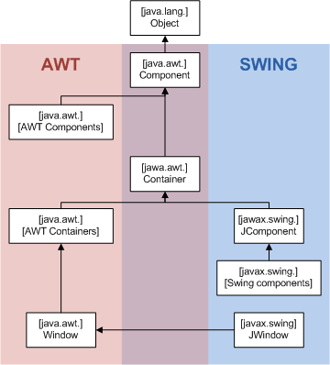The javax.swing package provides classes for java swing API such as JButton, JTextField, JTextArea, JRadioButton, JCheckbox, JMenu, JColorChooser etc.

**JDBC:**

* Java Database Connectivity (JDBC) is an application programming interface (API) for the programming language Java, which defines how a client may access a database.
* It is a Java-based data access technology used for Java database connectivity.
* 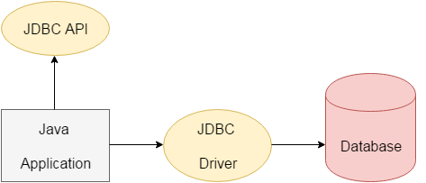It is part of the Java Standard Edition platform, from Oracle Corporation

**SYSTEM ARCHITECTURE**

* Two tier architecture is similar to a basic **client-server** model. The application at the client end directly communicates with the database at the server side
* API’s like ODBC, JDBC are used for this interaction. The server side is responsible for providing query processing and transaction management functionalities. On the client side, the user interfaces and application programs are run.
* The application on the client side establishes a connection with the server side in order to communicate with the DBMS.
* An advantage of this type is that maintenance and understanding is easier, compatible with existing systems. However, this model gives poor performance when there are a large number of users.

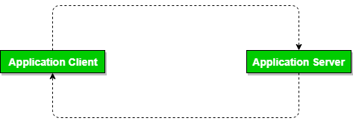

**ANALYSIS**

**FEASIBILITY ANALYSIS:**

* Whatever we think need not be feasible. It is wise to think about the feasibility of any problem we undertake. Feasibility is the study of impact, which happens in the organization by the development of a system. The impact can be either positive or negative. When the positives nominate the negatives, then the system is considered feasible. Here the feasibility study can be performed in two ways such as technical feasibility and Economical Feasibility.

**Technical Feasibility:**

* We can strongly say that it is technically feasible, since there will not be much difficulty in getting required resources for the development and maintaining the system as well. All the resources needed for the development of the software as well as the maintenance of the same is available in the organization here we are utilizing the resources which are available already.

**Economic Feasibility:**

* Development of this application is highly economically feasible. The organization needed not spend much m one for the development of the system already available. The only thing is to be done is making an environment for the development with an effective supervision. I f we are doing so, we can attain the maximum usability of the corresponding resources. Even after the development, the organization will not be in a condition to invest more in the organization. Therefore, the system is economically feasible.

**DESIGN**

* It is a process of planning a new business system or replacing an existing system by defining its components or modules to satisfy the specific requirements.
* Before planning, you need to understand the old system thoroughly and determine how computers can best be used in order to operate efficiently.
* System Design focuses on how to accomplish the objective of the system.

**AGILE SDLC MODEL**

* 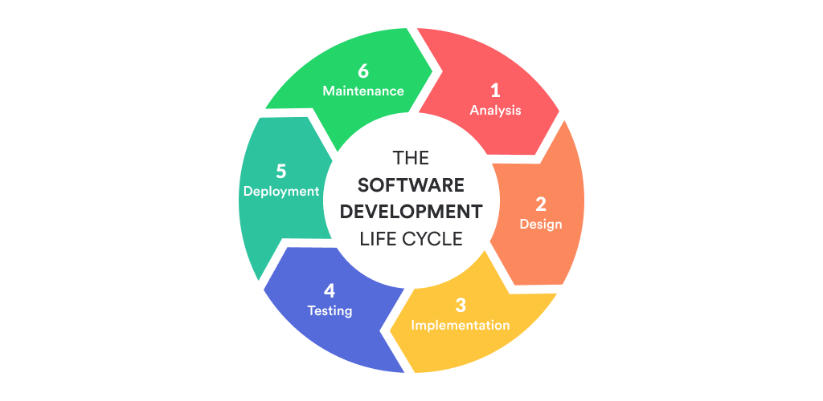Agile SDLC model is a combination of iterative and incremental process models with focus on process adaptability and customer satisfaction by rapid delivery of working software product.
* Agile Methods break the product into small incremental builds. These builds are provided in iterations.
* Each iteration typically lasts from about one to three weeks.

The Agile thought process had started early in the software development and started becoming popular with time due to its flexibility and adaptability.

The most popular Agile methods include Rational Unified Process (1994), Scrum (1995), Crystal Clear, Extreme Programming (1996), Adaptive Software Development, Feature Driven Development, and Dynamic Systems Development Method (DSDM) (1995). These are now collectively referred to as Agile Methodologies, after the Agile Manifesto was published in 2001.

Following are the Agile Manifesto principles −

* Individuals and interactions − In Agile development, self-organization and motivation are important, as are interactions like co-location and pair programming.
* Working software − Demo working software is considered the best means of communication with the customers to understand their requirements, instead of just depending on documentation.
* Customer collaboration − As the requirements cannot be gathered completely in the beginning of the project due to various factors, continuous customer interaction is very important to get proper product requirements.
* Responding to change − Agile Development is focused on quick responses to change and continuous development.

Agile Vs Traditional SDLC Models

Agile is based on the adaptive software development methods, whereas the traditional SDLC models like the waterfall model is based on a predictive approach. Predictive teams in the traditional SDLC models usually work with detailed planning and have a complete forecast of the exact tasks and features to be delivered in the next few months or during the product life cycle.

Predictive methods entirely depend on the requirement analysis and planning done in the beginning of cycle. Any changes to be incorporated go through a strict change control management and prioritization.

Agile uses an adaptive approach where there is no detailed planning and there is clarity on future tasks only in respect of what features need to be developed. There is feature driven development and the team adapts to the changing product requirements dynamically. The product is tested very frequently, through the release iterations, minimizing the risk of any major failures in future. Customer Interaction is the backbone of this Agile methodology, and open communication with minimum documentation are the typical features of Agile development environment. The agile teams work in close collaboration with each other and are most often located in the same geographical location.

**Agile Model - Pros and Cons**

Agile methods are being widely accepted in the software world recently. However, this method may not always be suitable for all products. Here are some pros and cons of the Agile model.

The advantages of the Agile Model are as follows −

* Is a very realistic approach to software development.
* Promotes teamwork and cross training.
* Functionality can be developed rapidly and demonstrated.
* Resource requirements are minimum.
* Suitable for fixed or changing requirements
* Delivers early partial working solutions.
* Good model for environments that change steadily.
* Minimal rules, documentation easily employed.
* Enables concurrent development and delivery within an overall planned context.
* Little or no planning required.
* Easy to manage.
* Gives flexibility to developers.

**The disadvantages of the Agile Model are as follows** −

* Not suitable for handling complex dependencies.
* More risk of sustainability, maintainability and extensibility.
* An overall plan, an agile leader and agile PM practice is a must without which it will not work.
* Strict delivery management dictates the scope, functionality to be delivered, and adjustments to meet the deadlines.
* Depends heavily on customer interaction, so if customer is not clear, team can be driven in the wrong direction.
* There is a very high individual dependency, since there is minimum documentation generated.
* Transfer of technology to new team members may be quite challenging due to lack of documentation.

**UML Diagrams:**

UML is a standard language for specifying, visualizing, constructing, and documenting the artifacts of software systems.

* UML stands for **Unified Modeling Language**.
* The building blocks of UML can be defined as –

1. Things
2. Relationships
3. Diagrams

* UML diagrams are the ultimate output of the entire discussion. All the elements, relationships are used to make a complete UML diagram and the diagram represents a system.
* The visual effect of the UML diagram is the most important part of the entire process. All the other elements are used to make it complete.

**SYSTEM USE CASE DIAGRAM**

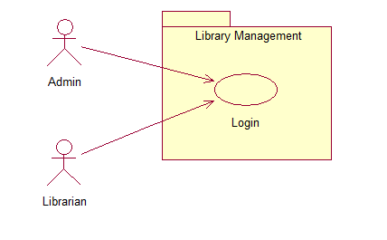

**ADMIN USE CASE DIAGRAM**

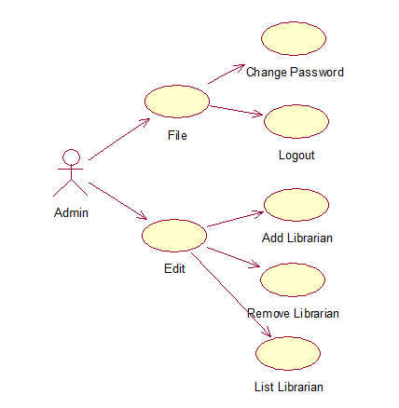

**LIBRARIAN USE CASE DIAGRAM**

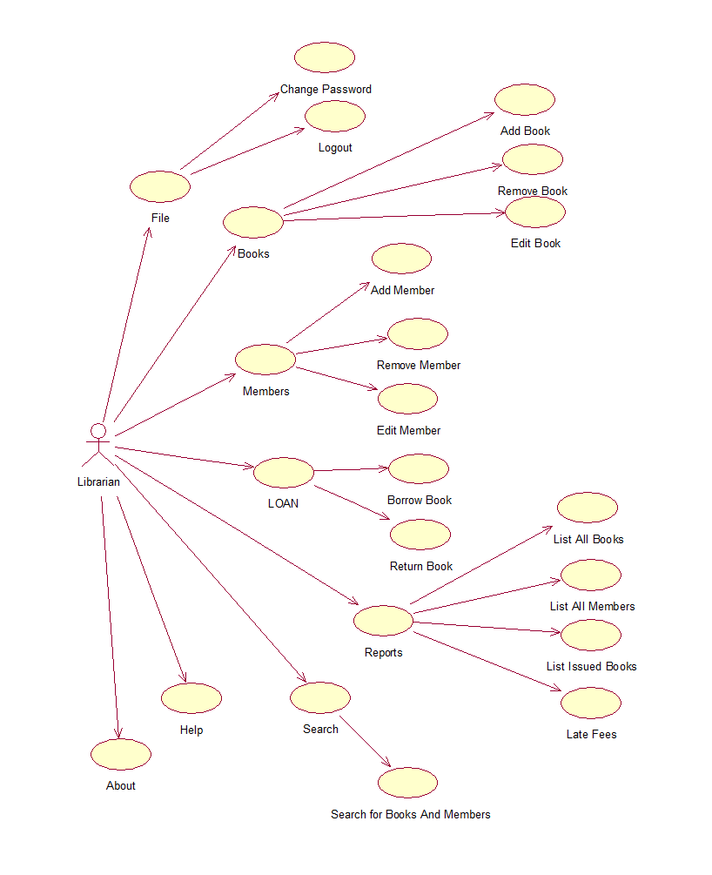

**CLASS DIAGRAM**

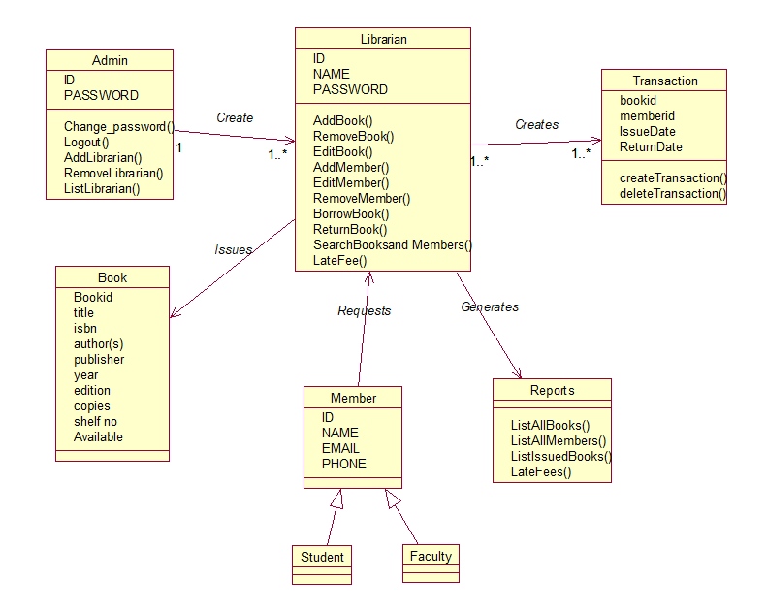

**SYSTEM ACTIVITY DIAGRAM**

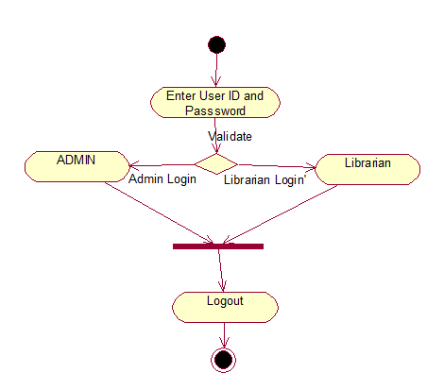

**ADMIN ACTIVITY DIAGRAM**

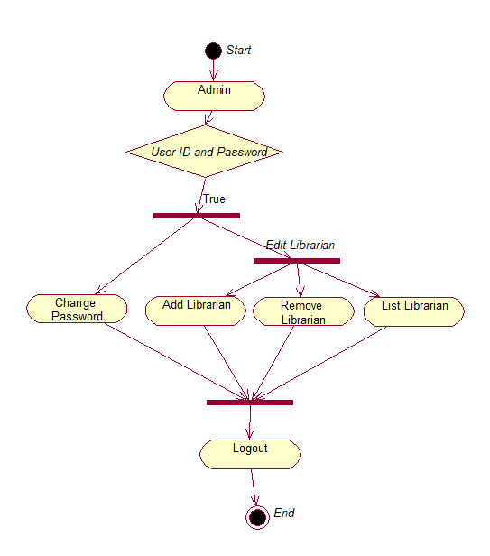

**ACTIVITY DIAGRAM**

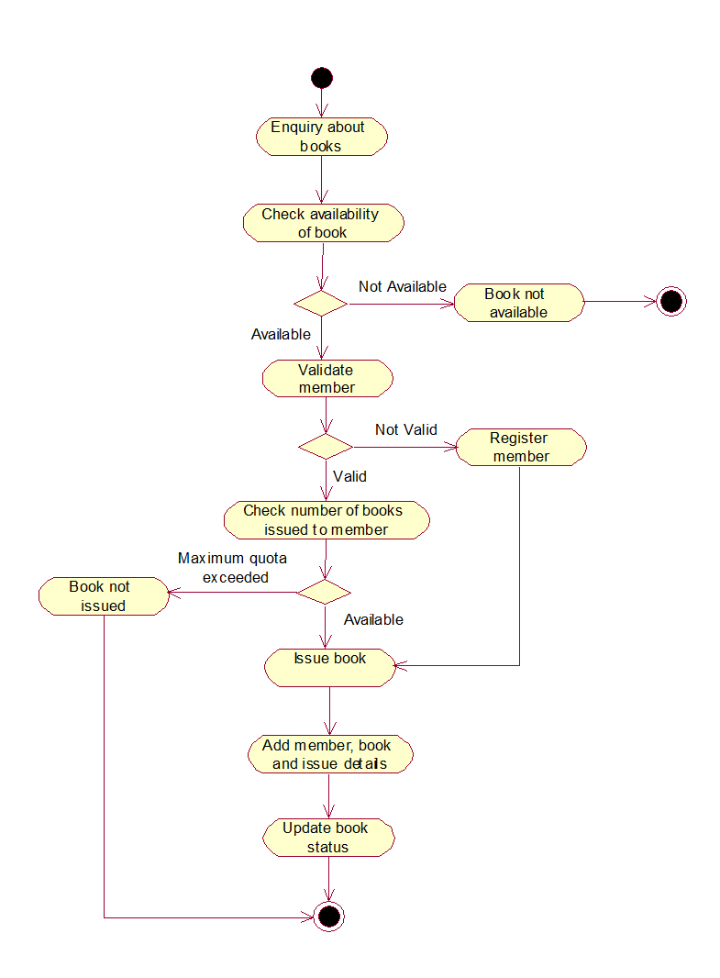

**LIBRARIAN ACTIVITY DIAGRAM**

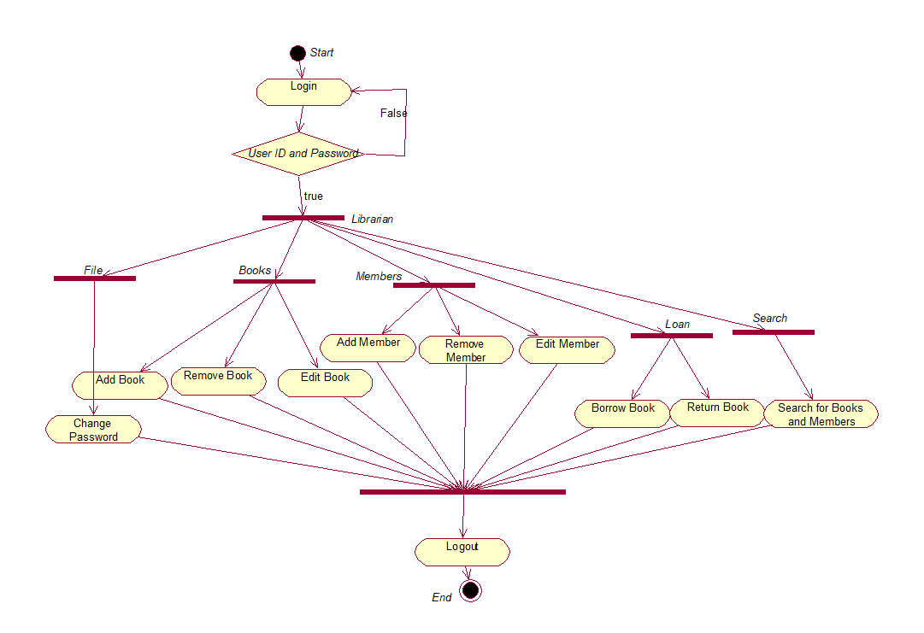

**ADMIN LOGIN SEQUENCE DIAGRAM**

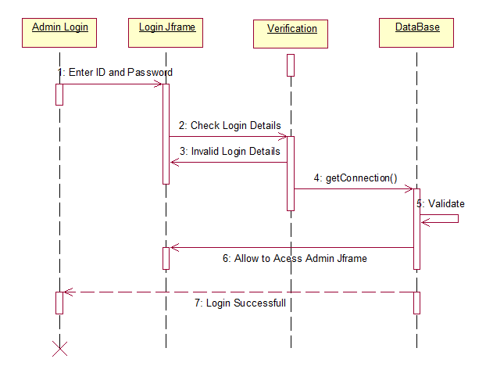

**LIBRARIAN LOGIN SEQUENCE DIAGRAM** 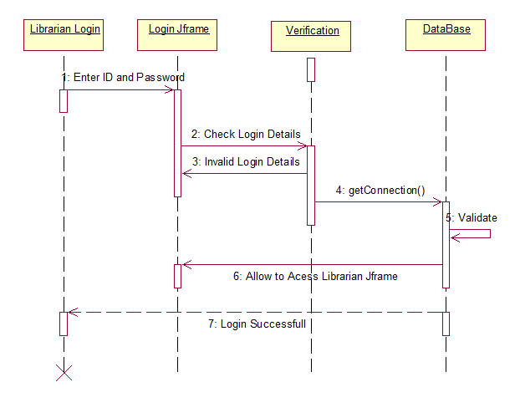

**ADMIN SEQUENCE DIAGRAM**

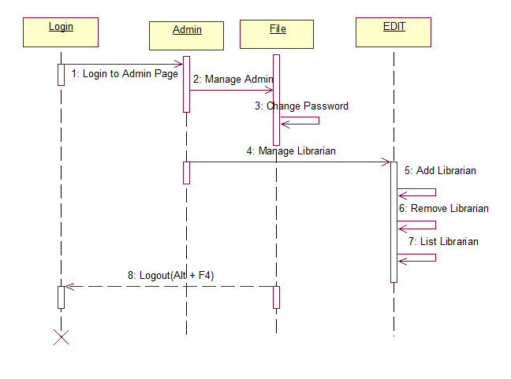

**LIBRARIAN SEQUENCE DIAGRAM** 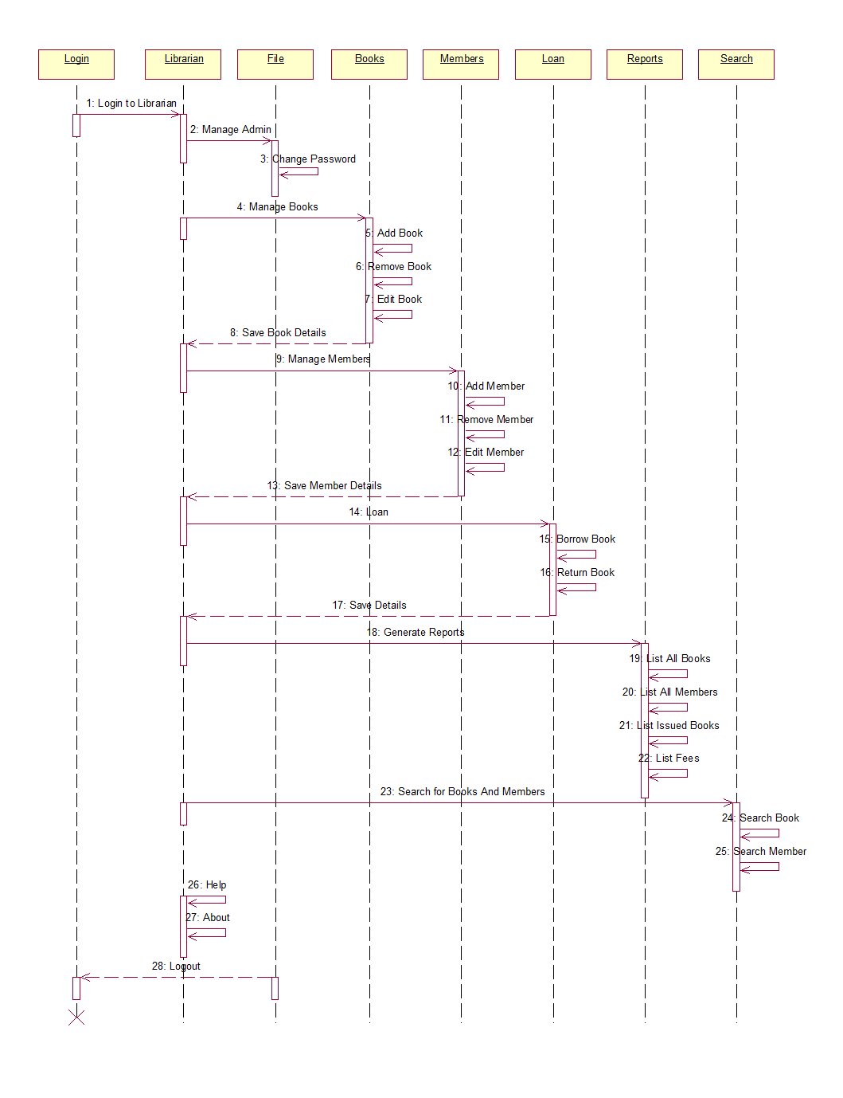

**STATE CHART DIAGRAM**

